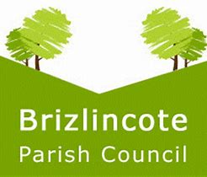
Clerk/Proper Officer, Mrs K Lear
Tel: 01283 533011
Email: clerk@brizlincote-pc.gov.uk

ANNUAL PARISH MEETING
THURSDAY 19TH MARCH 2026

ALL PARISHIONERS ARE INVITED TO ATTEND THE ANNUAL PARISH MEETING FOR BRIZLINCOTE

To be held in
The Lightfoot Lounge, The Grove, 6.30 pm

This is your opportunity to bring any concerns that you may have to the attention of the Parish Council.

Hope you can join us

Cllr Lynne Campion, Chair

